**Instruction to run the code**

To run the code OPEN MYSQL Administrator, then click on Restore on the left of your screen.

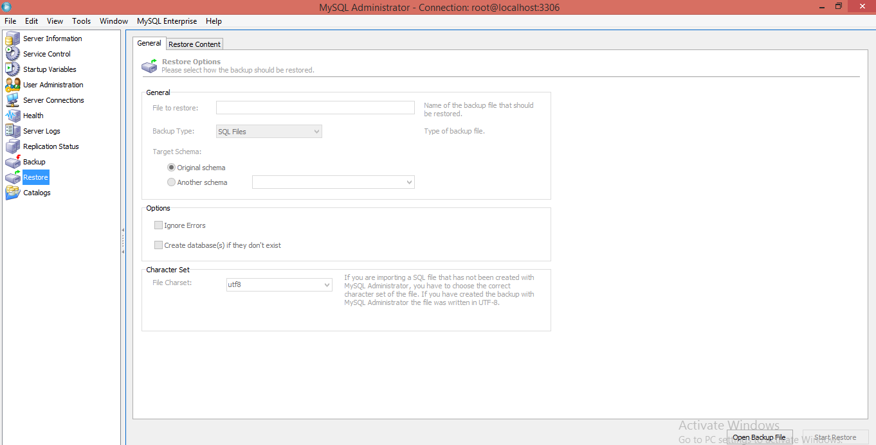

Then click on open backup file and select the **Employee\_data.sql** file.

After selecting the file click on Start Restore.

This process will create a database and tables.

**Task 1:** Create three tables with relevant keys as suggested in the above diagram

**Sol:-**

Employee TABLE

DROP TABLE IF EXISTS `employee`;

CREATE TABLE `employee` (

`employee\_id` int(11) NOT NULL auto\_increment,

`Empname` varchar(25) NOT NULL,

`Managerid` int(11) NOT NULL,

`Dateofhire` date NOT NULL,

`Jobname` varchar(15) NOT NULL,

`Salary` decimal(10,2) NOT NULL,

`department\_id` int(11) NOT NULL,

`DOB` date NOT NULL,

`address` varchar(30) NOT NULL,

PRIMARY KEY (`employee\_id`),

KEY `FK\_employee\_1` (`department\_id`),

CONSTRAINT `FK\_employee\_1` FOREIGN KEY (`department\_id`) REFERENCES `department` (`department\_id`)

) ENGINE=InnoDB AUTO\_INCREMENT=1012 DEFAULT CHARSET=utf8;

Department TABLE

DROP TABLE IF EXISTS `department`;

CREATE TABLE `department` (

`department\_id` int(11) NOT NULL default '0',

`Deptname` varchar(30) default NULL,

`deptLocation` varchar(20) default NULL,

`deptFloor` varchar(20) default NULL,

PRIMARY KEY (`department\_id`)

) ENGINE=InnoDB DEFAULT CHARSET=utf8;

Salary TABLE

DROP TABLE IF EXISTS `salary`;

CREATE TABLE `salary` (

`salary\_level` int(11) NOT NULL default '0',

`salarymin` int(11) default NULL,

`salarymax` int(11) default NULL,

PRIMARY KEY USING BTREE (`salary\_level`)

) ENGINE=InnoDB DEFAULT CHARSET=utf8;

**Task 2:** Insert record of 10 employees in the employee table

**Sol:-**

INSERT INTO `employee` (`employee\_id`,`Empname`,`Managerid`,`Dateofhire`,`Jobname`,`Salary`,`department\_id`,`DOB`,`address`) VALUES

(1001,'Mark',5001,'2000-08-01','PROGRAMMER','90000.00',902,'1994-05-23','101 Park Street LA'),

(1002,'Mary',5002,'2017-08-23','TESTER','100000.00',902,'1990-04-27','101 Mark Street LA'),

(1003,'Faith',5003,'2018-06-10','HR MANAGER','25000.00',903,'1988-05-05','101 Royal casa LA'),

(1004,'Natalia',5004,'2018-05-26','MANAGER','96000.00',903,'1994-06-28','101 Wardha LA'),

(1005,'Flynn',5005,'2019-12-27','ELECTRICAL ENGG','56000.00',904,'1987-07-29','101 Uchha Kuaa LA'),

(1006,'Max',5006,'2016-07-19','IT MANAGER','19000.00',901,'1994-03-10','101 Lal Kuwa LA'),

(1007,'Ronny',5007,'2018-03-18','PROGRAMMER','27000.00',902,'1990-02-08','101 Mandi House LA'),

(1008,'Sheing',5008,'2014-09-28','ELECTRICAL ENGG','34000.00',904,'1991-01-05','101 Opera Street LA'),

(1009,'Robert',5009,'2019-07-05','MAINTENANCE','78400.00',905,'1993-07-21','101 Nariman House LA'),

(1010,'Kareena',5010,'2015-06-03','TESTER','120000.00',902,'1994-08-24','101 Henton house LA'),

(1011,'Janet',5095,'2014-10-12','PROGRAMMER','90000.00',2011,'1994-08-24','101 Henton house LA');

**Task 3:** Insert record of 5 departments in the department table

**Sol:-**

INSERT INTO `department` (`department\_id`,`Deptname`,`deptLocation`,`deptFloor`) VALUES

(901,'IT','LONDON','1ST'),

(902,'ENGG','LONDON','2ND'),

(903,'HR','LONDON','3RD'),

(904,'ELECTRICAL','LONDON','4TH'),

(905,'MAINTENANCE','LONDON','5TH'),

(2011,'PROGRAMMER1','PARIS','6TH');

**Task 4:** Insert record of 5 salary levels in the salary table

**Sol:-**

INSERT INTO `salary` (`salary\_level`,`salarymin`,`salarymax`) VALUES

(1,15000,30000),

(2,30001,50000),

(3,50001,70000),

(4,70001,90000),

(5,90001,120000);

**Task 5:** Write a query to display the information about the employees in the employee

table

**Sol:-** SELECT \* FROM employee e;

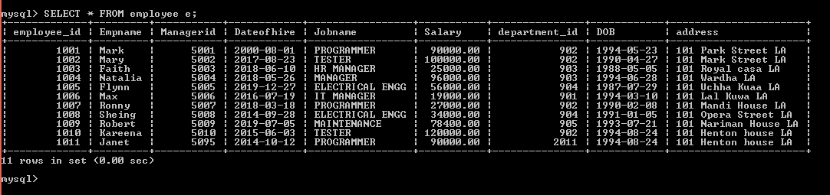

**Task 6:** Write a query to display the name of all the employees

**Sol:-** select Empname from EMPLOYEE;

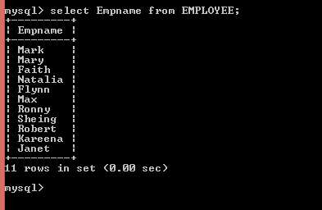

**Task 7:** Write a query to display the name of all the employees and their jobname.

**Sol:-** select Empname, Jobname from EMPLOYEE;

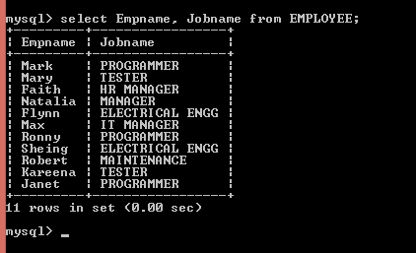

**Task 8:** Write a query in SQL to display the unique jobname for all the employees

**Sol:-** select DISTINCT Jobname from EMPLOYEE;

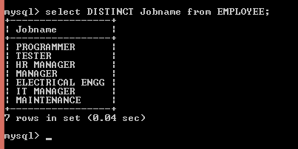

**Task 9:** Write a query to increase the salary for all the employees by 12%. Display the

empname, jobname and salary after the increment

**Sol:-** SELECT Empname, Jobname, Salary + (Salary \* 12/100) as NewSalary from EMPLOYEE;

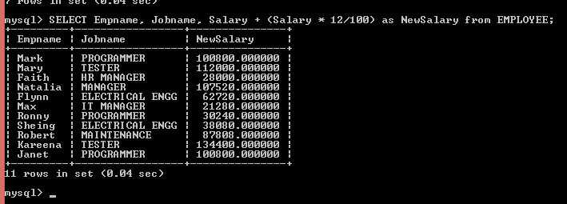

**Task 10:** Write a query to display the employee names with minimum and maximum

salary.

**Sol:-** SELECT Empname, Salary FROM EMPLOYEE WHERE Salary in((SELECT MAX(Salary) FROM EMPLOYEE),(SELECT MIN(Salary) FROM EMPLOYEE ));

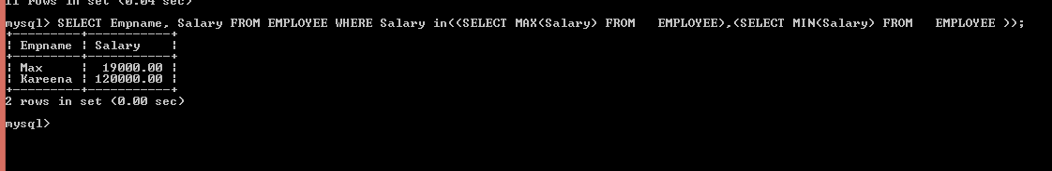

**Task 11:** Write a query to display the employee id, employee name, jobname of all the

employees whose salary is greater than 90,000 P.A.

**Sol:-** SELECT employee\_id, Empname, Jobname from EMPLOYEE where Salary>90000;

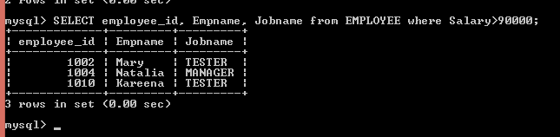

**Task 12:** write a query to display the all the details of all the employees whose jobname

is Manager. (Hint: While entering the records for employee, make sure to add manager

as jobname for a few employees.)

**Sol:-** SELECT \* from EMPLOYEE where Jobname= 'MANAGER';

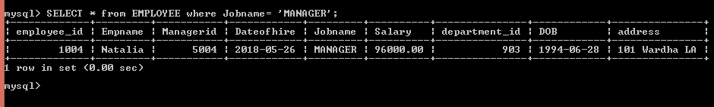

**Task 13:** Write a query to display the all the details of the employee whose name is

Robert. (Hint: While entering the records for employee, make sure to add Robert as

empname for at least one employee.)

**Sol:-** SELECT \* from EMPLOYEE where Empname= 'Robert';

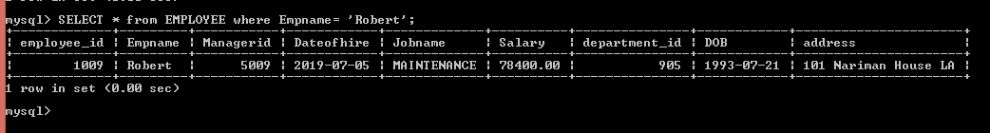

**Task 14:** Write a query to display all the details of the employee who work as a

manager and have salary greater than 95000 P.A.

**Sol:-** SELECT \* from EMPLOYEE where Jobname= 'MANAGER' AND Salary>95000;

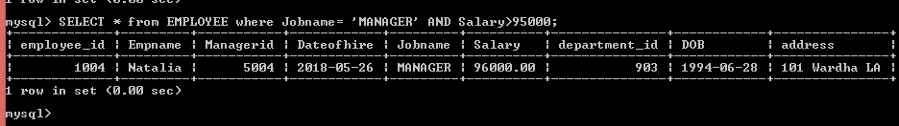

**Task 15:** Write a query to display employeeid, employee name, jobname and date of

joining of all the employees who joined after year 2001.

**Sol:-** SELECT employee\_id, Empname, Jobname, Dateofhire from EMPLOYEE WHERE Dateofhire>('2001-12-31');

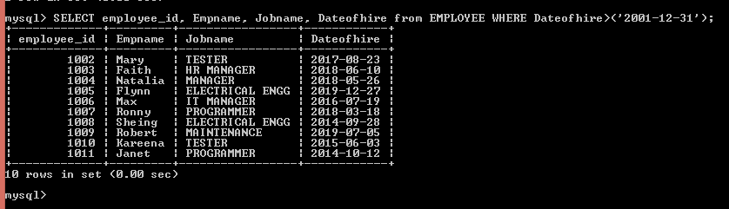

**Task 16:** Write a query to display the list of all the employees whose annual salary is

within the range 55000 and 95000.( Hint: make sure to add the salary in this range

while entering records in the employee table)

**Sol:-** SELECT \* from EMPLOYEE where Salary>55000 AND Salary<95000;

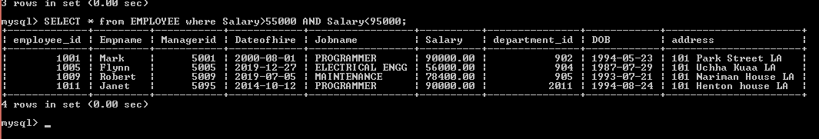

**Task 17:** Write a query to display the list of all the employees in the descending order

of their salaries.

**Sol:-** SELECT \* from EMPLOYEE ORDER BY Salary DESC;

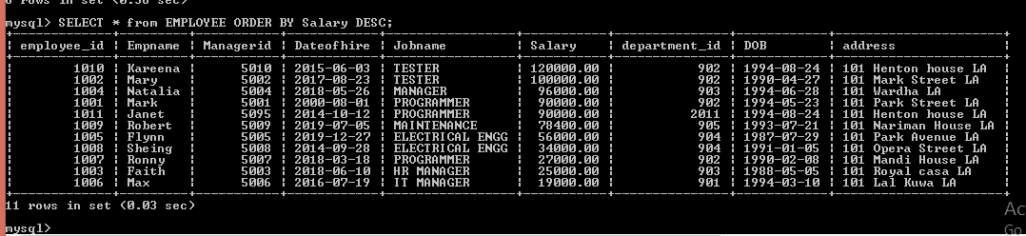

**Task 18:** Write a query to count the number of employees in the employee table.

**Sol:-** SELECT COUNT(employee\_id) AS NumberOfEmployee FROM EMPLOYEE;

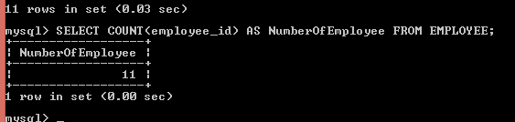

**Task 19:** Insert a new record in the employee table and add ANALYST as their jobname.

The other fields can be added as per your choice

**Sol:-** insert into EMPLOYEE(employee\_id, Empname, Managerid, Dateofhire , Jobname, Salary, department\_id, DOB, address) values(1012, "Nyka", 5010, "2015-06-03", "ANALYST", 120000.00, 902, "1994-08-24", "101 Henton house LA");

C:\Users\SRISHTI_PC\Pictures\Screenshots\Screenshot (177).png

**Task 20:** Insert a new record in the employee table with the following data fields

employee\_id= 1011

empname= Janet

jobname= PROGRAMMER

managerid= 5095

dateofhire= 12-10-2014

salary= 90000

department\_id=2011

**Sol:-** insert into EMPLOYEE(employee\_id, Empname, Managerid, Dateofhire , Jobname, Salary, department\_id, DOB, address) values(1011, "Janet", 5095, "2014-10-12", "PROGRAMMER", 90000.00, 2011, "1994-08-24", "101 Henton house LA");

C:\Users\SRISHTI_PC\Pictures\Screenshots\Screenshot (177).png

**Task 21:** Write a query to delete the record of the employee whose name is ‘Flynn’.

(Hint: Make sure to add a record with employee name ‘Flynn’ in the beginning.

**Sol:-**Delete from EMPLOYEE where Empname= 'Flynn';

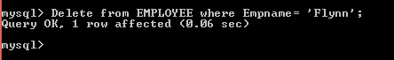

**Task 22:** Write a query to update the salary by 15% of the employee whose employee

name is ROBERT.

**Sol:-** UPDATE EMPLOYEE SET Salary = Salary + (Salary \* 15/100) WHERE Empname='ROBERT';

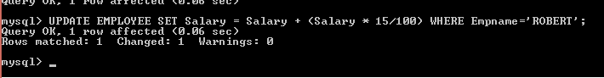

**Task 23:** Write a query to find the number of staff working in each department and the

sum of their salaries.

**Sol:-** select sum(salary), count(department\_id) from employee group by department\_id;

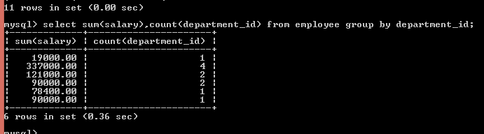

**Task 24:** Write a query to find all employees with the string ‘Avenue’ in their address

**Sol:-** select \* from EMPLOYEE where address like ‘%Avenue%’;

**